**OverbookMyShow**

Name: Gaurav Mehra

SAP ID: 40315220002

Class/Roll No.: SYBSC D042

**Introduction**

OverbookMyShow (OBMS) is an event management and ticketing application designed to streamline the process of organizing and attending events. With OBMS, event managers can effortlessly create and manage events while users can easily discover and purchase tickets for their favorite events.

**Objectives**

* Develop a user-friendly event management and ticketing application.
* Provide a seamless experience for event organizers and attendees.
* Allow event organizers to efficiently manage events and ticket sales.
* Enable users to easily browse events, purchase tickets, and manage their profile.

**Features (User + Admin)**

* Sign Up/Login to Account – The user can sign up for a new OBMS account, or login to their existing account. The authentication process is done using Firebase authentication.
* Browse Events – The user can browse events on the home page of the app. These include a summary of each event currently stored in the database.
* View Event Details – The user can click on a specific event and view all information about the event, like the event name, description, date and time, venue, and most importantly the number of tickets left, and their prices.
* Purchase Tickets – There are 4 types of tickets – VIP, Platinum, Silver, Gold. The user can select the number of tickets he/she wants to buy. Once they proceed to buy, the quantity of the tickets is checked from the database and if tickets are available, the tickets are allotted to the user.
* View Profile – The user can view their profile, which includes basic information like the user’s name, email, and role (User/Admin).
* View Purchased Tickets – The user can view the tickets he/she has purchased, which they would have to show while entering the event, for a smooth check-in experience.

**Features (Admin Only)**

* Create New Events – The admin can create new events, which would be added to the database. The admin needs to provide information like event name, description, date and time, venue, quantity and price of each type of ticket.
* Scan Tickets at Check-In – The admin can scan users’ tickets before they enter the event to make sure that the same ticket is not being used twice, the changes are reflected live in the database.

**Technology Stack**

* Programming language: Dart
* Framework: Flutter
* Authentication: Firebase Authentication
* Database: Firebase Cloud Firestore

**Pages**

* Landing Page

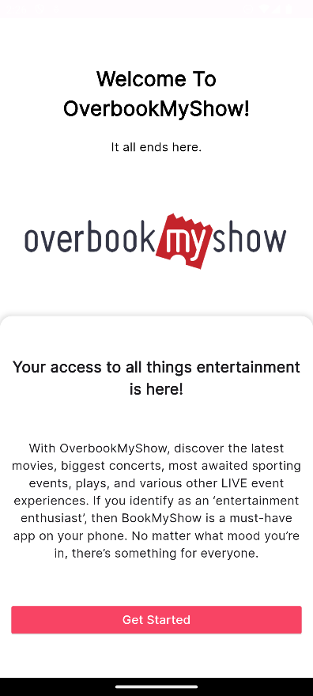

* Sign Up and Login Page

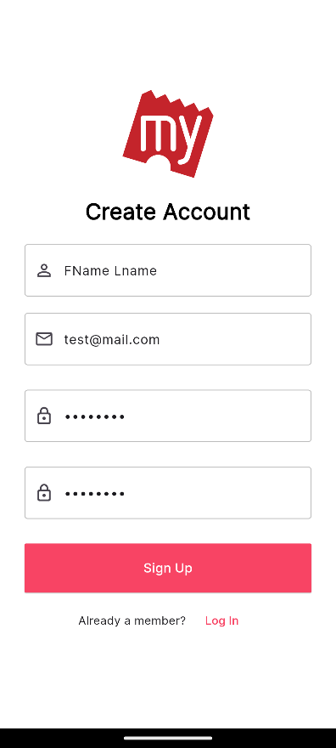 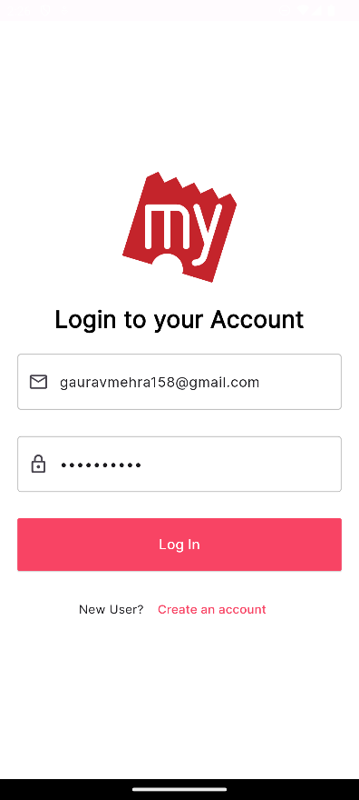

* Home Page

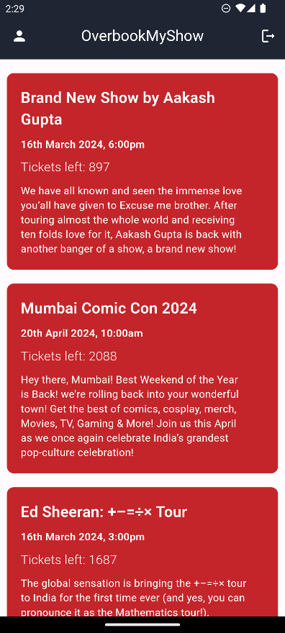

* Event Page

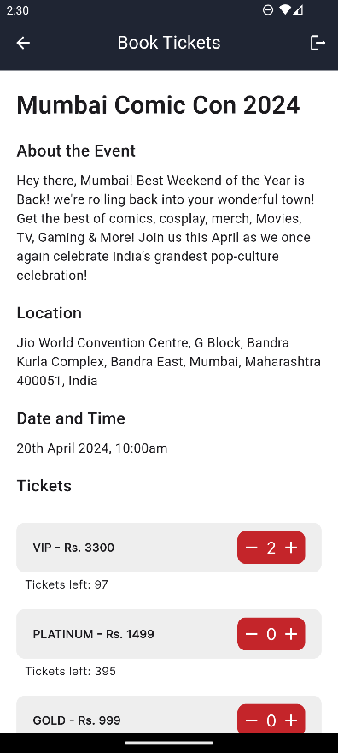

* Profile Page

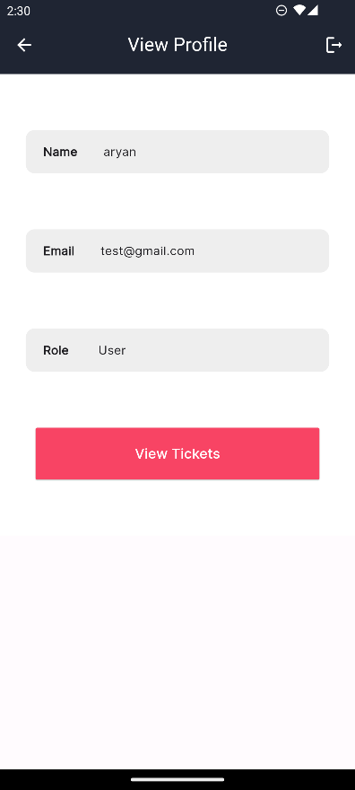 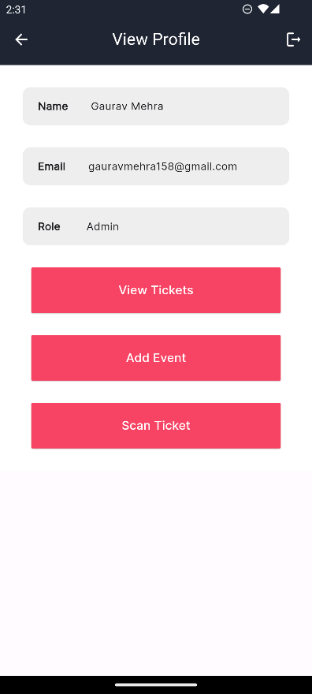

* Tickets Page

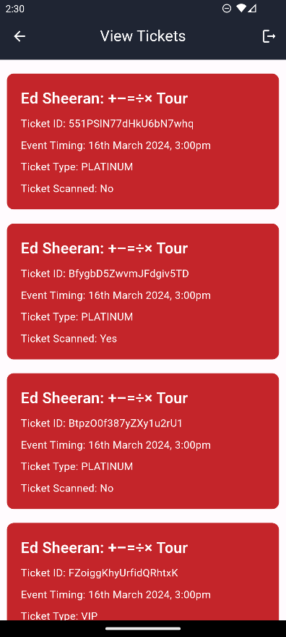

* Add Event Page (Admin)

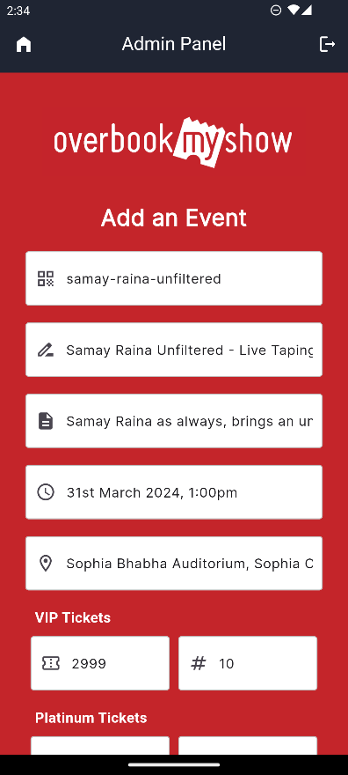

* Scan Ticket Page (Admin)

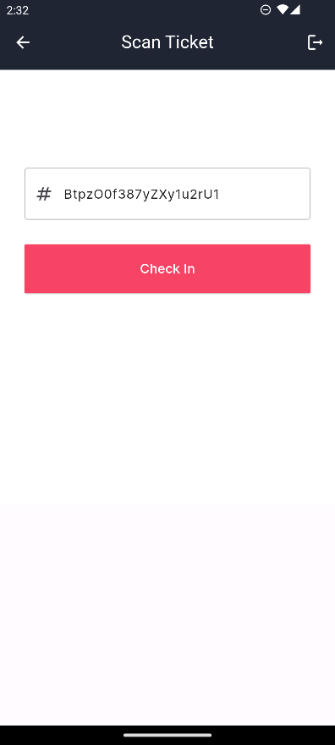

**GitHub Repository Link**

https://www.github.com/gauravmehraa/OverbookMyShow